**Software Requirement Specification**

**Interactive Web Portal**

MAHAMUD HASAN [s299742]

HITAKSHI [s300774]

SHRIJANA BHANDARI [s300775]

MOHAMMAD NAHID HASSAN SAGAR [s300464]

MANTHANKUMAR CHHAGANBHAI VAGHANI [s299843]

# 1. Introduction

This section gives a scope description and overview of everything included in SRS document. Also, the purpose of this document is provided along with abbreviations and list of definitions.

## 1.1 Purpose

Primary, the purpose of the document is that to provide detailed information of interactive web portal application. Moreover, it will reveal the instances along with the description of the document of the particular application. It will also explain the restrictions of the system, user interface and user interactions. Since interactive web portal is proposed according to customer’s choice. Therefore, the purpose is of the document is the first approval from the customer and requires a reference for producing the latest version of the system for the development team.

## 1.2 Scope

### Justification

The business statement of provided project named Interactive Web Portal is that it is a community based interactive project that is somehow exhibits a bridge between community and management. However, multiple users can be controlled by single administrator. Basically, interactive web portal is a centralized and personalized type of system that may come across with various interesting and mandatory features.

### Product scope description

Myriad characteristics can be acknowledged such as registration of new member, password changing ability. Users can also utilize services of general form such that they can suggest, complaint or request related to the post. Primary, the most interesting and beneficial feature is that the convenience of e-card.

### Acceptance criteria

To meet the specific target of accomplishment of project, planning of project is essential. The team leader needs to divide the tasks to other team members by judging their ability. In the documentation, feasibility study will consume more time to understand the whole structure and requirements of project. Moreover, SRS document, development and testing are the procedures.

### Deliverables

The project will produce a community web portal that includes latest news, digital resources, policy, budgetary information, comments, separate profile and posts.

### Project Exclusion

The project will not accomplish the planning of future events by administrator and also there should be not an event calendar. Also, only administrator can post on the wall, users can not. Users can only comment what is their reaction about that specific post that too by the approval of administrator.

### Constraints

Time restrictions are there that the completion of project should be in 13 weeks. If the completion is still pending then we can seek for extension of project.

### Assumptions

If we are not certain about some things in our project then we will consult with our supervisor and will go for a meeting with our client. Also, we can get information from internet.

## 1.3 Definitions, acronyms, and abbreviations

|  |  |
| --- | --- |
| **Term** | **Definition** |
| User | Someone who interacts with the community application |
| Administrator | Someone who has the authority to monitor and control the system |
| Owner | Someone who is linked with a religious place and relate it with application |
| Web-Portal | A web application which is processed for community purposes |
| E-card | Unique card for every user |
| Application store | An installed application on mobile phone which help user to access mobile phone platform and download from internet |
| Stakeholder | Any person who interacts with the system but not a developer |
|  |  |

## 1.4 Overview

## The remainder of this document includes three chapters and appendixes. The second one provides an overview of the system functionality and system interaction with other systems. This chapter also introduces the admin and member interact with the system. Further, the chapter also mentions the system constraints and assumptions about the product.

## The third chapter provides the requirements specification in detailed terms and a description of the different system interfaces. Different specification techniques are used to specify the requirements more precisely for different audiences.

## The fourth chapter deals with the prioritization of the requirements. It includes a motivation for the chosen prioritization methods and discusses why other alternatives were not chosen.

## The Appendixes in the end of the document include the all results of the requirement prioritization and a release plan based on them.

# 2. Overall description

Entire system will be described in this section. It shows that how system works between admin and member and their functionality. It also describes that what type of functionality will be given to Admin and member. At last, the constraints and assumptions for the system will be presented.

## 2.1 Product perspective

This system will consist of two types of user. One is admin and other one is member. In web portal Admin will control everything. Such as member’s approval, generate membership card, posting event, approval of member’s comments and all other sorts of things managed by the web portal system. All the information will store in a database and web portal will communicate with database for every information.

## 2.2 Product functions

With this web portal, the users can register themselves to a community. Administrator of the community will approve his membership. After being registered member will get a electronic member ship card. They can join any kind of community activity with this card. They know every news, every post, every event about the community using this system.

Member will be part of the digital library about the community in the system. The web portal will provide functionality to manage a community. It will also provide information about the system, for example show when there is a new update.

## 2.3 User characteristics

There are two types of users that interact with the system: Admin of the community web portal and member of the community. Each of these types of users has different use of the system so each of them has their own requirements.

The member can only view in their profile. In that profile, they will know what is going on in the community. Member can view and post a comment on admin’s post. They can read the news and know about the admins posted events. User can access digital resources provided by the community. The administrator is the only one who can control everything in the web portal.

## 2.4 Constraints

The Internet connection is also a constraint for the application. Since the application fetches data from the database over the Internet, it is crucial that there is an Internet connection for the application to function. Capacity of Database is also the constraint of the web portal. Since the database is shared in the application for every member it may be forced to queue incoming requests and therefor increase the time it takes to fetch data.

## 2.5 Assumptions and dependencies

There are only one dependencies about this product because this web portal can be used in any laptop, mobile if those device is connected through internet connection.

# 3. Specific requirements

With this section, we will give detailed description of the requirements of the system. Its gives a detailed description of the system and all its features. There are two types of requirements which are External interface requirements and functional requirements.

# 3.1 External interface Requirements

Detailed description of all input and output from the system are being described here. It also provides the description of the hardware, software, communication interfaces and basic prototypes.

## 3.1.1 User interfaces

User always see the homepage of web portal. Then the user can choose either s/he want to login as Admin or login as Member. If s/he is not registered member yet then s/he must do the registration first.

Every user should have a profile page where user can edit their information like email address, phone number, home address, password etc.

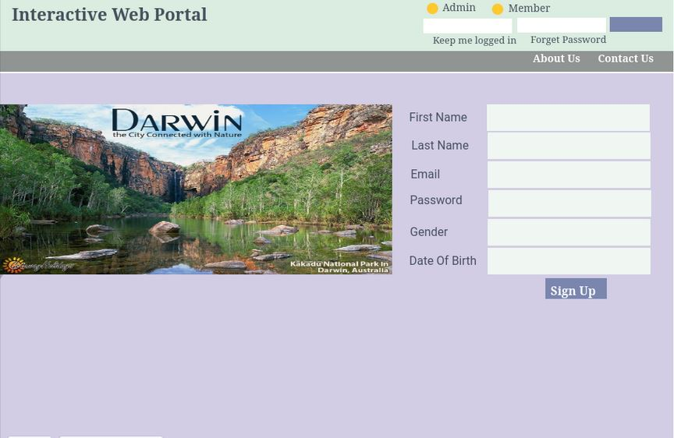

Figure:1

This is the Homepage. Here is registration part, login part and Forgot Password part. User can do their registration from here. They also can login from here as Admin or Member.

After registration Admin will get the request and after admin’s approval user will get mail from admin with membership card.

Card will be like this.

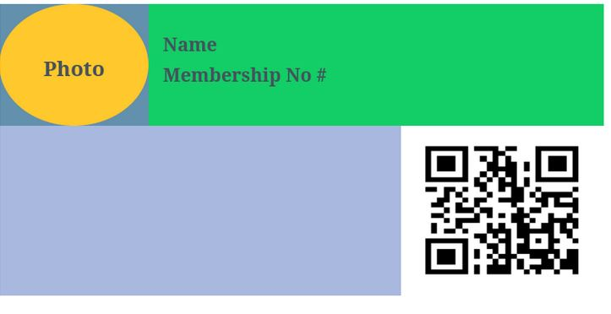

There will photo and name and membership no. in the card. Here is membership no generation criteria. The membership number will be generated as **ALN DD MM YYYY + any random number**.

ex: ALN1503201700001

So, its ALN+ current date + 5-digit sequence number.

After successful registration, user can login as a member in their page. Page will be like this.

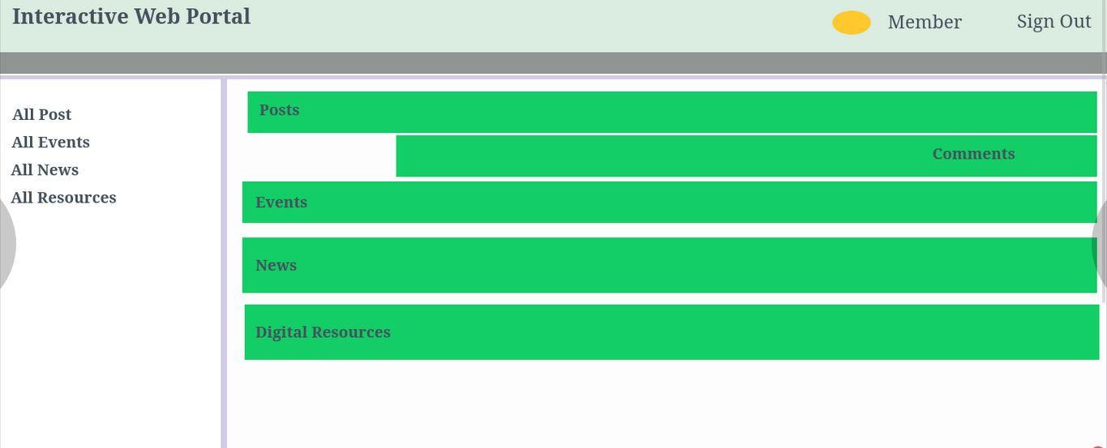

Here user can just observe all the posts and events, news and resources. User can comment on every post and give their feedback.

There is a general form here for request/suggestion/complain/others. And admin will view all the request from admin page.

Here is the admin page

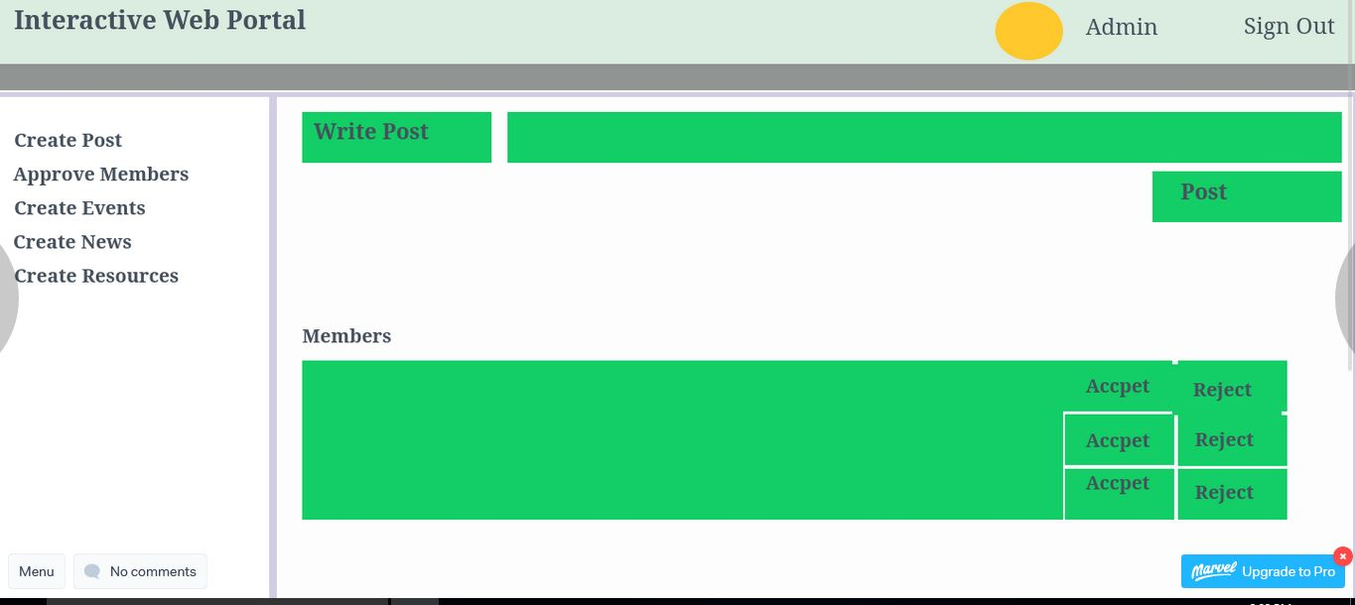

Admin can create post, approve user, create events, add news and upload digital resources like pdf, documents, books here. If User does not meet registration criteria then admin can reject or mail them to provide necessary documents.

## 3.1.2 Hardware interfaces

Since this is a web application so it will provide minimum hardware requirements. The following hardware configurations are required for a PC using the web portal application:

* Intel Core i3 processor
* 1 GB of free hard drive space
* 1GB of RAM

## 3.1.3 Software interfaces

Admin and member will communicate with the web portal application. User can registration and login. User also can view the posted event by admin and can comment on that post. User can reset the password via mail. Also download the digital resources and read the news. Admin can approve the user registration request and comment on admin’s post. All sort of things store and manage by database server. To run this system efficiently following tools are needed:

* Operating System: Windows
* Web Brower: Internet Explorer, Mozilla Firefox, or Google Chrome
* Integrated Development Environment: Visual Studio
* Database: MySQL

## 3.1.4 Communications interfaces

The communication between the admin and member of the system is important since they depend on each other. Internet will be only way to communicate with each other. SSL will be the connection.

## 3.2 Functional requirements

This section describes the all sorts of functionality of the interactive web portal.

## 3.2.1 User Class 1 - The User

## 3.2.1.1 Functional requirement 1.1

ID: FR1

TITLE: User registration

DESC: A user should be able to do the registration. The user must provide user-name, password and e-mail address. The user can choose to provide a regularly used phone number.

## 3.2.1.2 Functional requirement 1.2

ID: FR2

TITLE: Reset Password

DESC: When a user forget their password they can recover it by mail.

## 3.2.1.3 Functional requirement 1.3

ID: FR3

TITLE: General form for request/suggestion/complain/other as a type of form.

DESC: There will be a common form where user can post the request and suggestion and complain from that form.

## 3.2.1.4 Functional requirement 1.4

ID: FR4

TITLE: Centralized Information.

DESC: Registered member’s information must be centralized and personalized.

## 3.2.1.5 Functional requirement 1.5

ID: FR5

TITLE: Submit comment by member

DESC: Each member will have separate profile that they can send email and submit their comments on the admin’s posts.

## 3.2.1.6 Functional requirement 1.6

ID: FR6

TITLE: Event plan by admin

DESC: Administrator can plan the events and set the date on an event calendar.

## 3.2.1.7 Functional requirement 1.7

ID: FR7

TITLE: Generate E-Membership card

DESC: After successful registration and approval from admin user get an E-Membership card. The membership number will be generated as ALN DD MM YYYY + any random number. Ex: ALN1503201700001

So, its ALN+current date + 5 digit sequence number.

## 3.2.1.8 Functional requirement 1.8

ID: FR8

TITLE: Compatible with all mobile devices.

DESC: Web portal pages compatible with all mobile devices.

## 3.2.1.9 Functional requirement 1.9

ID: FR9

TITLE: Full admin control

DESC: Admin has every control of everting in web portal. They can approve user registration, approve user comment on the post, and upload digital recourses for user.

Admin can upload news that user can see from their profile and organize event from event calendar.

## 3.2.1.10 Functional requirement 1.10

ID: FR10

TITLE: Member’s comment on the post

DESC: Member can comment on the admin’s post and if admin approve it then it will visualize.